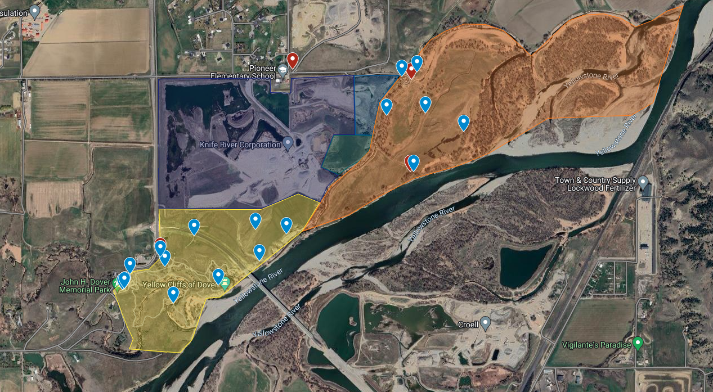

HQ, entrances, bathrooms
Area 3 Headquarters

Bathroom

Area 3 Projects
House Projects-Fix/clean root cellar, install new fence panels, clean out rafters of outbuildings, windows/floors/surfaces of old house, etc. Also coat of whitewash on outside and coat of deck stain on porch.
Provided by YRPA(Need brushes, buckets, whitewash, deck stain, cleaner, tarps/plastic sheeting.)

Coral- Dismantle old corral structures under guidance of local rancher/leaseholder

Slough fencing-Install of smooth wire fencing to keep cattle out of wetland area

Area 3 Headquarters
Pioneer School
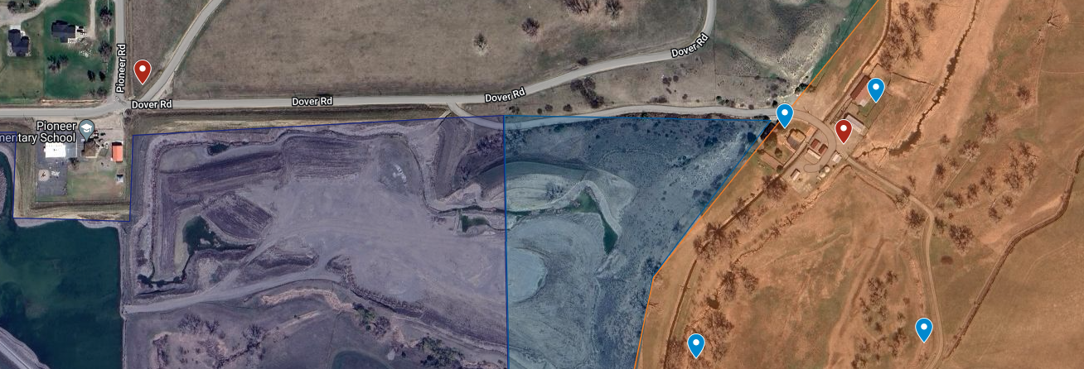
Area 3 Gray Zone HQ
Area 3 and 4 entrance
Church Vans Park at Pioneer School Park Church Vans will carpool participants to project
Gate Keeper
Gate Keeper

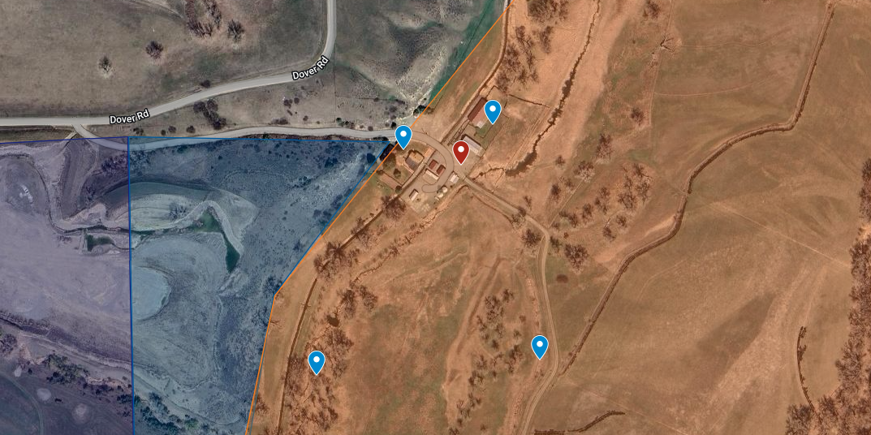
Area 4 Yellow Zone Russian Olive Removal
Porta Potty
Area 3 Headquarters
Slough Fencing
Coral
House Projects
Area 3 Gray Flag

